SCHOOL OF COMPUTER SCIENCE AND ARTIFICIAL INTELLIGENCE |  |  |  |  | DEPARTMENT OF COMPUTER SCIENCE ENGINEERING
ProgramName:B. Tech |  |  |  | Assignment Type: Lab |  |  | AcademicYear:2025-2026
CourseCoordinatorName |  |  |  | Venkataramana Veeramsetty
Instructor(s)Name
  Dr. V. Venkataramana (Co-ordinator)
  Dr. T. Sampath Kumar
  Dr. Pramoda Patro
  Dr. Brij Kishor Tiwari
  Dr.J.Ravichander
  Dr. Mohammand Ali Shaik
  Dr. Anirodh Kumar
  Mr. S.Naresh Kumar
  Dr. RAJESH VELPULA
  Mr. Kundhan Kumar
  Ms. Ch.Rajitha
  Mr. M Prakash
  Mr. B.Raju
  Intern 1 (Dharma teja)
  Intern 2 (Sai Prasad)
  Intern 3 (Sowmya)
  NS_2 ( Mounika)
CourseCode |  |  | 24CS002PC215 | CourseTitle |  | AI Assisted Coding
Year/Sem |  |  | II/I | Regulation |  | R24
Date and Day  of Assignment |  |  | Week3 - Wednesday | Time(s)
Duration |  |  | 2 Hours | Applicableto  Batches
AssignmentNumber:6.3(Present assignment number)/24(Total number of assignments)
 | Q.No. | Question |  |  |  |  |  | ExpectedTime  to complete
 | 1 | Lab 6: AI-Based Code Completion – Classes, Loops, and Conditionals  Lab Objectives:  - To explore AI-powered auto-completion features for core Python constructs.  - To analyze how AI suggests logic for class definitions, loops, and conditionals.  - To evaluate the completeness and correctness of code generated by AI assistants.  Lab Outcomes (LOs):  After completing this lab, students will be able to:  - Use AI tools to generate and complete class definitions and methods.  - Understand and assess AI-suggested loops for iterative tasks.  - Generate conditional statements through prompt-driven suggestions.  - Critically evaluate AI-assisted code for correctness and clarity.  Task Description#1 (Classes)  - Use AI to complete a Student class with attributes and a method.  - Check output  - Analyze the code generated by AI tool  INPUT:  rom dataclasses import dataclass, field  from typing import List  @dataclass  class Student:  """Represents a student with basic academic information."""  full_name: str  age_years: int  grades: List[float] = field(default_factory=list)  def grade_point_average(self) -> float:  """Compute the average of numeric grades. Returns 0.0 if there are no grades."""  if not self.grades:  return 0.0  total_points: float = sum(self.grades)  num_courses: int = len(self.grades)  return total_points / num_courses  def describe(self) -> str:  """Return a human-readable summary of the student's info and GPA."""  gpa_value: float = self.grade_point_average()  return f"{self.full_name}, age {self.age_years}, GPA: {gpa_value:.2f}"  def _demo() -> None:  """Run a simple demonstration of the Student class."""  student = Student(full_name="Alex Johnson", age_years=20, grades=[88.0, 92.5, 79.0, 85.5])  print("Student summary:")  print(student.describe())  print("Raw GPA:", f"{student.grade_point_average():.4f}")  if __name__ == "__main__":  _demo()  Expected Output#1  - Class with constructor and display_details() method  OUTPUT :  Student summary:  Alex Johnson, age 20, GPA: 86.25  Raw GPA: 86.2500  PS C:\Users\Anjali>  Task Description#2 (Loops)  - Prompt AI to complete a function that prints the first 10 multiples of a number using a loop.  - Analyze the generated code  - Ask AI to generate code using other controlled looping  INPUT :  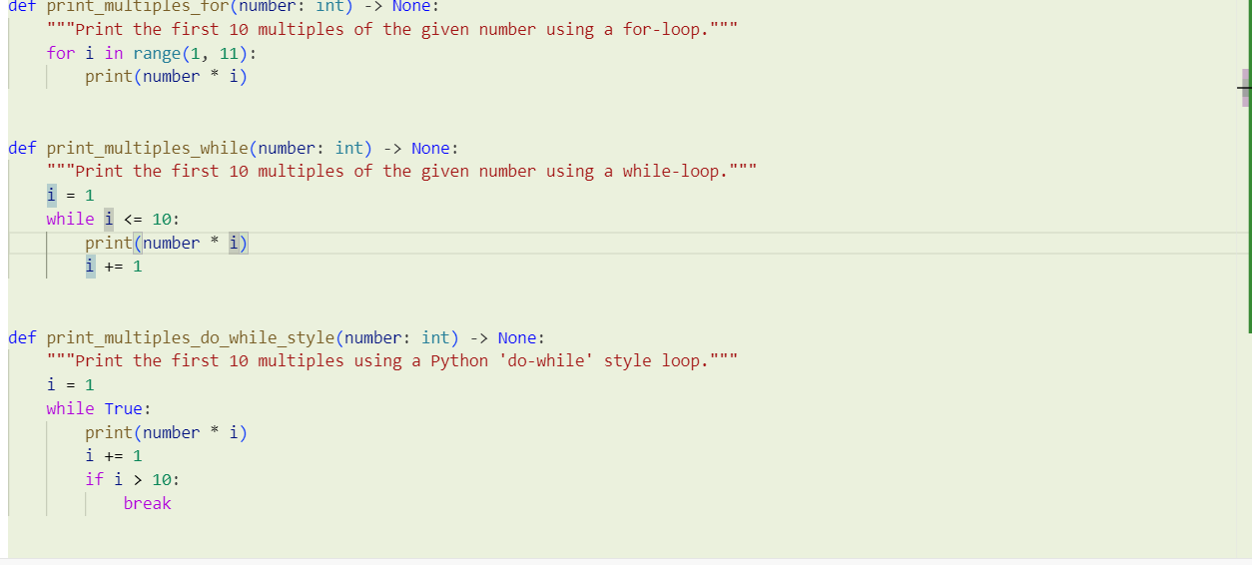  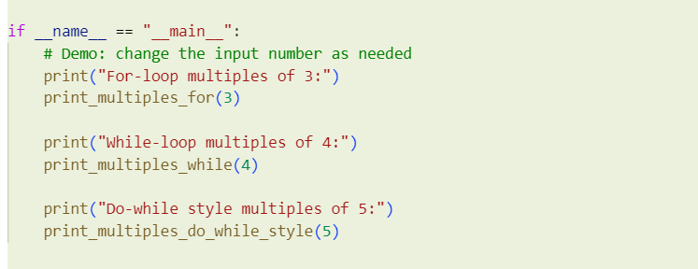  - Correct loop-based implementation  OUTPUT :  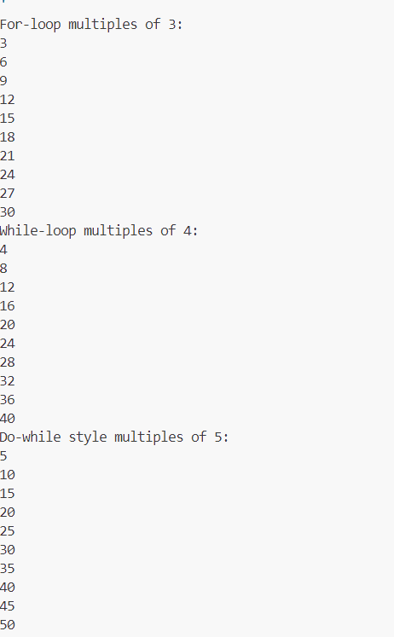  Task Description#3 (Conditional Statements)  - Ask AI to write nested if-elif-else conditionals to classify age groups.  - Analyze the generated code  - Ask AI to generate code using other conditional statements  INPUT :  ef classify_age(age: int) -> str:  """Classify age into groups using nested if-elif-else conditionals.  Groups:  - Invalid (< 0)  - Infant (0-2)  - Child (3-12)  - Teen (13-17)  - Adult (18-64)  - Senior (65+)  """  if age < 0:  return "Invalid"  else:  if age <= 2:  return "Infant"  elif age <= 12:  return "Child"  else:  if age <= 17:  return "Teen"  elif age <= 64:  return "Adult"  else:  return "Senior"  def classify_age_flat(age: int) -> str:  """Same classification using flat guard-clause style (non-nested)."""  if age < 0:  return "Invalid"  if age <= 2:  return "Infant"  if age <= 12:  return "Child"  if age <= 17:  return "Teen"  if age <= 64:  return "Adult"  return "Senior"  def classify_age_bisect(age: int) -> str:  """Classification using thresholds with bisect for maintainability."""  from bisect import bisect_right  if age < 0:  return "Invalid"  thresholds = [2, 12, 17, 64, float("inf")]  labels = ["Infant", "Child", "Teen", "Adult", "Senior"]  idx = bisect_right(thresholds, age)  return labels[idx]  if __name__ == "__main__":  try:  user_text = input("Enter age (integer): ").strip()  age = int(user_text)  except Exception:  print("Invalid input. Please enter an integer.")  else:  print("Nested:", classify_age(age))  print("Flat:", classify_age_flat(age))  print("Bisect:", classify_age_bisect(age))  Expected Output#3  - Invalid: ages < 0 are rejected explicitly.  - Infant: 0–2 (inclusive) using age ≤ 2.  - Child: 3–12 via age ≤ 12 after ruling out ≤ 2.  - Teen: 13–17 via age ≤ 17 in the deeper branch.  - Adult: 18–64 via age ≤ 64.  - Senior: 65+ is the remaining case.  OUTPUT:  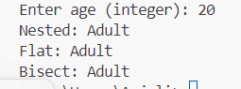  Task Description#4 (For and While loops)  - looping Generate a sum_to_n() function to calculate sum of first n numbers  - Analyze the generated code  - Get suggestions from AI with other controlled  CODE:  def sum_to_n_loop(n: int) -> int:  """Return sum of first n natural numbers using a loop.  Raises ValueError if n is negative or not an integer.  """  if int(n) != n or n < 0:  raise ValueError("n must be a non-negative integer")  n = int(n)  total = 0  for i in range(1, n + 1):  total += i  return total  def sum_to_n_formula(n: int) -> int:  """Return sum of first n natural numbers using closed-form formula."""  if int(n) != n or n < 0:  raise ValueError("n must be a non-negative integer")  n = int(n)  return n * (n + 1) // 2  def sum_to_n_generator(n: int):  """Yield cumulative sums up to n (useful if you need intermediate sums)."""  if int(n) != n or n < 0:  raise ValueError("n must be a non-negative integer")  n = int(n)  total = 0  for i in range(1, n + 1):  total += i  yield total  # Example usage  if __name__ == "__main__":  print("Loop sum to 10:", sum_to_n_loop(10)) # 55  print("Formula sum to 10:", sum_to_n_formula(10)) # 55  print("Generator cumulative sums to 5:", list(sum_to_n_generator(5))) # [1,3,6,10,15]  Expected Output#4  - Python code with explanation  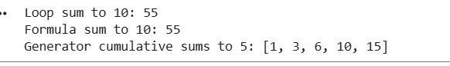  EXPLANATION:  Function 1: sum_to_n_loop()  This version uses a for loop to calculate the sum step-by-step.  Steps:  - Validate the input — must be a non-negative integer.  - Start with total = 0.  - Loop from 1 to n, adding each number to total.  - After the loop finishes, return the final total.  Example (n = 5):  ✅ Result: 15  Time Complexity: O(n)  Space Complexity: O(1)  🔹 Function 2: sum_to_n_formula()  This version uses the mathematical formula for the sum of the first n natural numbers:  $$S=\frac{n(n+1)}{2}$$  Explanation:  - Derived from the arithmetic series formula.  - No loop needed — just one calculation.  - The // operator ensures the result is an integer.  Example (n = 10):  $$S=\frac{10(10+1)}{2}=\frac{110}{2}=55$$  ✅ Result: 55  Time Complexity: O(1)  Space Complexity: O(1)  🔹 Function 3: sum_to_n_generator()  This version uses a generator (the yield keyword) to produce cumulative sums one by one.  How it works:  - Each time the function encounters yield, it pauses and sends the current total to the caller.  - When resumed, it continues from where it left off.  Example (n = 5):  Generated sequence:  1 → 3 → 6 → 10 → 15  So if you convert it to a list:  list(sum_to_n_generator(5))  # Output: [1, 3, 6, 10, 15]  ✅ Result: [1, 3, 6, 10, 15]  Time Complexity: O(n)  Space Complexity: O(1) — generator yields one value at a time.  ⚖️ Comparison Table  🧾 Program Output  Using loop: 55  Using formula: 55  Using generator: [1, 3, 6, 10, 15]  Task Description#5 (Class)  - Use AI to build a BankAccount class with deposit, withdraw, and balance methods.  - Analyze the generated code  - Add comments and explain code  Expected Output#5  - Python code with explanation  INPUT::  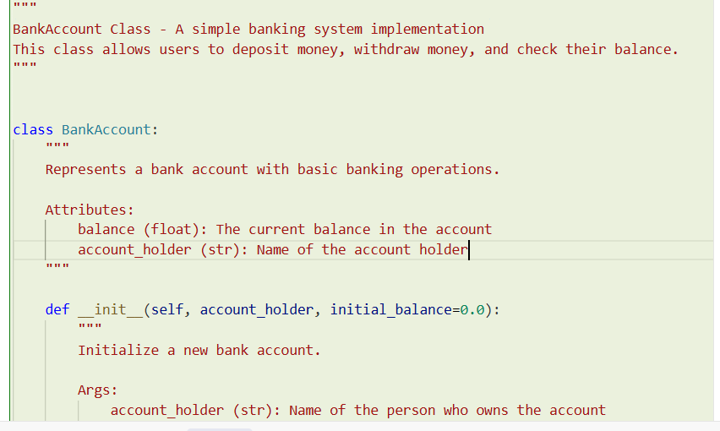  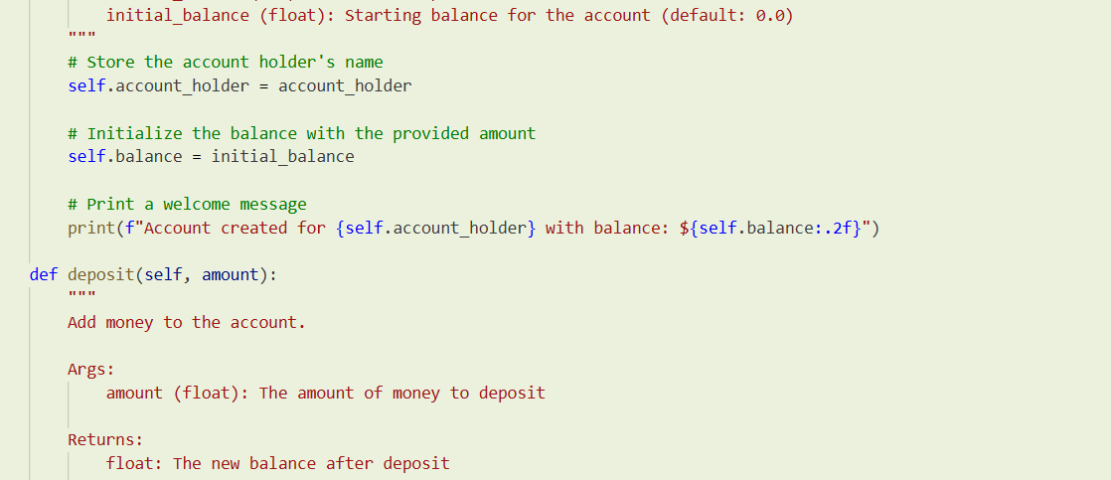  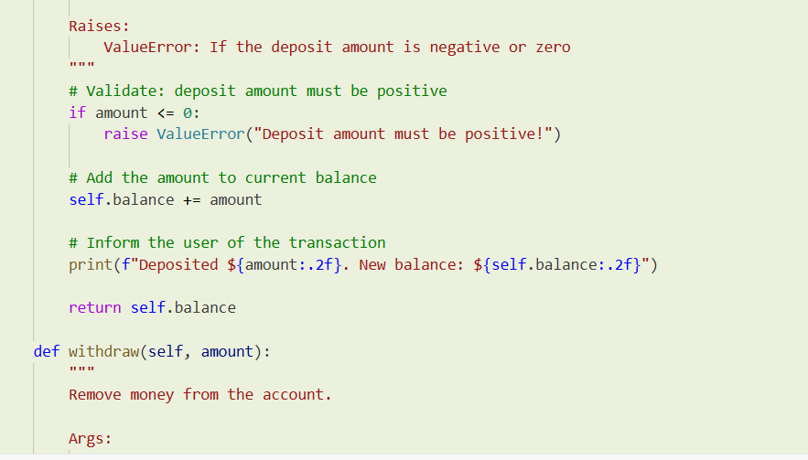  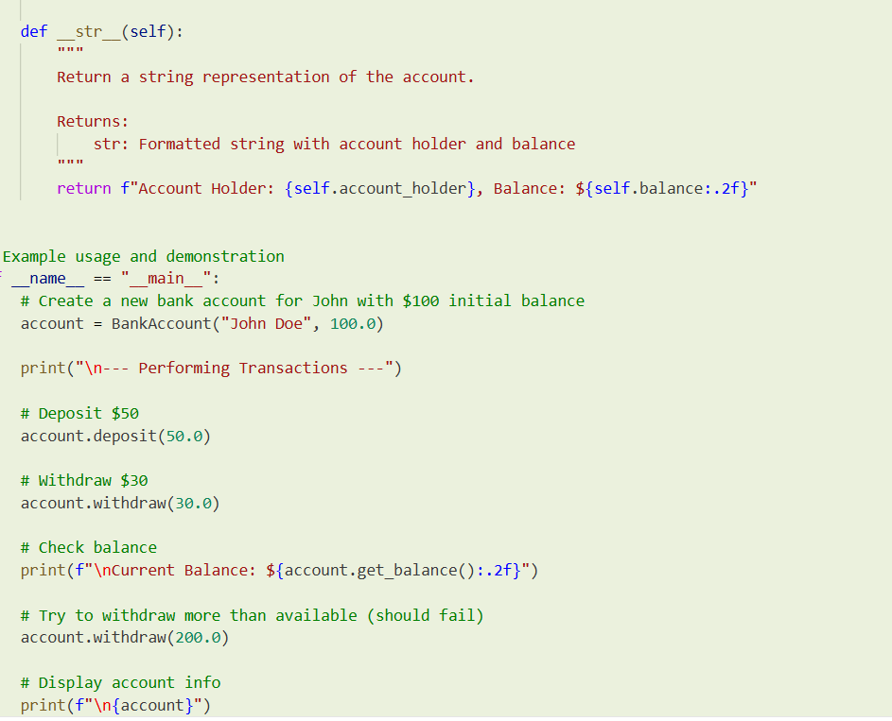  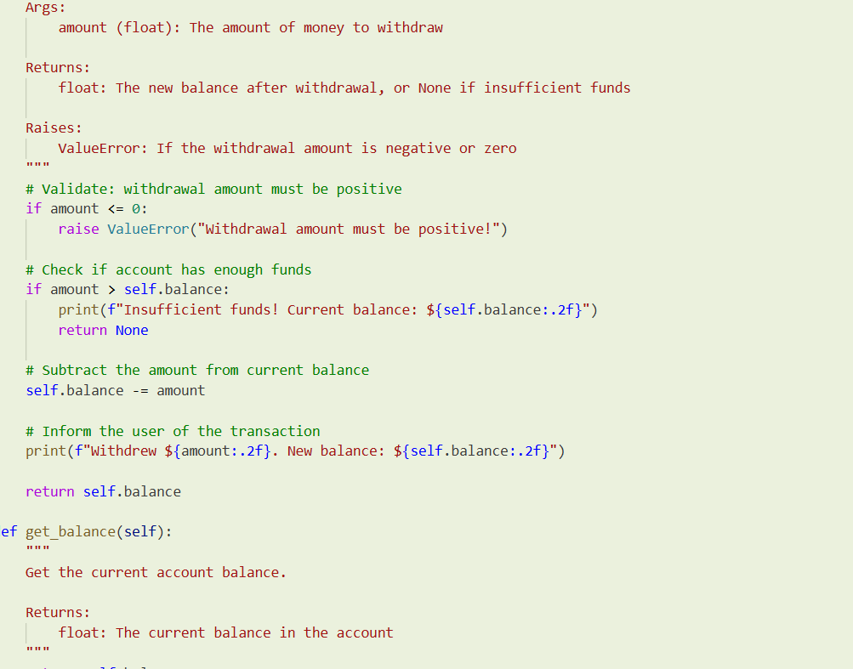  OUTPUT:  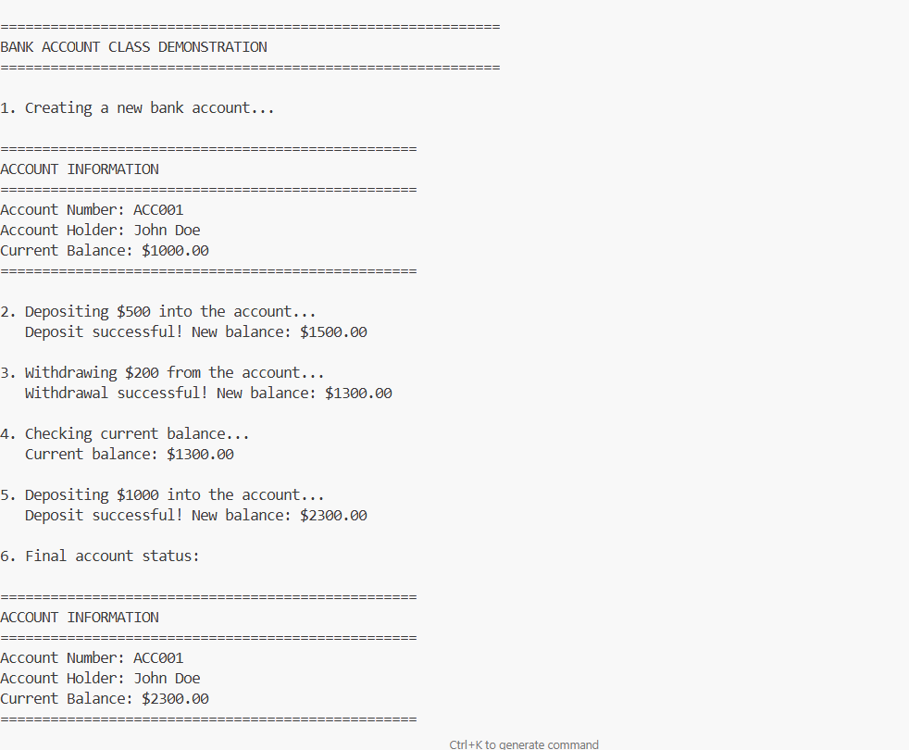  Note: Report should be submitted a word document for all tasks in a single document with prompts, comments & code explanation, and output and if required, screenshots  Evaluation Criteria: |  |  |  |  |  | Week3 - Wednesday
  Iteration | i | total (before) | total (after)
  1 | 1 | 0 | 1
  2 | 2 | 1 | 3
  3 | 3 | 3 | 6
  4 | 4 | 6 | 10
  5 | 5 | 10 | 15
  Function | Approach | Output | Speed | Memory | Best For
  sum_to_n_loop() | Looping | Final sum | Medium (O(n)) | Low | Teaching iteration / step logic
  sum_to_n_formula() | Formula | Final sum | Fast (O(1)) | Low | Large numbers, performance
  sum_to_n_generator() | Generator | Sequence of sums | Medium (O(n)) | Very Low | Streaming / progressive output
  Criteria | Max Marks
  Class | 1.0
  Loops | 1.0
  Conditional Statements | 0.5
  Total | 2.5 Marks

